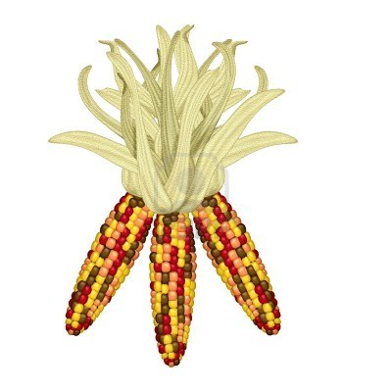
2B Weekly Fridge Sheet
Monday, November 16, 2015
Skills We’re Learning:

Spelling: long o (o, oa, ow & oe)

Reading: Making inferences & generating questions
Story of the week:
There’s Nothing Like Baseball
Homework: Read pages 268-285.

Grammar: Plurals and Possessives and using Apostrophes

Math: Subtracting 2-digit numbers with and without regrouping

Science - Habitats

Vocabulary Words to Know:
imaginary- existing only in the mind
uniform- special or official clothes that members of a group wear
practices- times set aside to work on skills
tryouts- tests to judge a person’s skills
starting- to be in a game at the beginning
coach- a person who trains people who play sports
2.5 Spelling Words

grow mow crow

toe goes toast

soap foam told

most light mind

float didn't they're

Challenge Words
*between
*few
*example
This Week:
Monday: Homework goes home
-Vocabulary Sheet
-Booklet (pull off, fold, read, sign)
-Read Story: Nothing Like Baseball
p. 268-285 (Listen, sign book card)

Friday: Spelling & Reading Test
**HOMEWORK DUE**
Have a Great Week! ☺Mrs. Rinehart
Sign, Clip, and Return Bottom Slip for a ticket!

Student Signature:___________________ Parent Signature:_______________________
Expires 11/20/15

Important Dates:
November 20 - Midterm

December 4 - Christmas Program 1:00!

